SYCA&IT (SEM – IV)
[Java Programming List]

- Write an Application program to print your name and address.
- Perform arithmetic operations [ add,sub,mul,div].
- Find out prime-palindrome numbers between 1 to 10,000
- Display output of series 1/1! - 1/2! + 1/3! - 1/4! + 1/5!...

- Fibonacci series.
- Enter marks of 3 three subjects, make total and percentage (using command line). Display grad,
  - “A” if per >=60
  - “B” if per 60< and >=50
  - “C” if per 50< and >=40
  - “F” if per 40<

- Create a method area(), overload it to calculate area of circle, rectangle and square.
- Calculate net salary of employee with following constraints by overloading salary().
    - If employee is manager, pass basic, da, hra, ma, pf, it, pt
    - If employee is executive, pass basic, da, hra, pf, it
    - If employee is jn_executive, pass basic, da, hra, it
    - If employee is peon, pass basic, da.

- Write a program for
- Check for positive or negative number
- Check for odd or even number
- Check for primary number
- Check for Palindrome number
- Check for Armstrong number
- Check for number whether a member of fibonacci series
- Exit

Create abstract methods for every check into abstract Proto1 class and define into Defi1 class and call from Menu1 class.

- Create arrays of 5 item. Pass item name, qty and rate. Ca`lculate and display net amount for each item. Also display item having highest net amount.
- A shop selling medicine and sports items. Display all information for each product. Product name, product prize, expire date, deases name, sports name, made material. (use inheritance).

- In a library there are educational books and magazines are available. In educational books, subjects are like physics and computer. The physics book contains number of practical. The computer book contains CD. The magazine categories are like commercial and sports. Display the info like, book name, book code, book price, subject code (P or C), Subject name, Number of practical, contains CD or not, Magazine name, commercial type, sport’s name. Calculate total number of educational books subject wise, magazines category wise. (Make the respective class final use hierarchical inheritance).

- Read employee details like, name, age, department, salary with following constraints
      - Age should not below 20 years and over 60 years.
      - Department must be ‘s’, ‘p’ or ‘a’.
      - Salary should be more than 1000, if it’s not than reset to 1000.

- Create class String1 to read a string and a character. Replace all occurrences with new character. Create class String2 to read a string and a substring. Replace all occurrences with new substring.

You are given a sting str =”sardar patel university”. Perform the following operation on it.
- find the length of string
- replace the character p’ by ‘r’
- convert all character in uppercase
extract and print “sardar” from given string.

- Read a string and restructure it as follows,
  - Input: “Java is useful language”
  - Output: “Javais use fullanguageX”
- Read a name and gender. Restructure it as follows, (Program should display message if gender is not m or f).
  - Input: Name: ABC DEFG HIJK
      - Gender: M
      - Name: PQR STU VWXYZ
      - Gender: F
  - Output: Name: Mr. A. D. HIJK
        - Name: Ms. P. S. VWXYZdfbdfbf
- Write a menu driven an Application program to do following.
Member variable: std_no,std_name,std_sub1,std_sub2,std_sub3,total,per
- New Student Entry
- Calculate student result
- Display specified student’s formatted Mark sheet
- Delete Student Entry
- Modify the Student info
- Exit
Note: use array of objects and read appropriate value on choice.

Applet

- Display house. “Sweet home” at the middle (using lines, arc, oval, rectangle, polygon)
- Change back ground color using 3 buttons
- Display coordinate of mouse click on status bar and Display coordinate of mouse move with mouse pointer.
- Enter two numbers in textboxes, select arithmetic operator and display the answer.
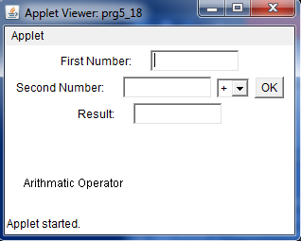
- Display check box
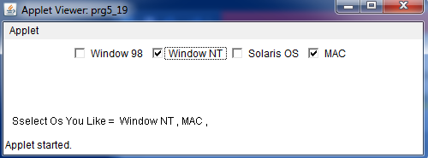
- 26. Display radio button
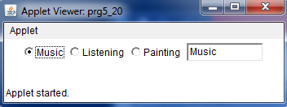
- 27. Display list for country -> state -> city. (Country and state is single selection, city is multi selected). Display selection on applet on button click
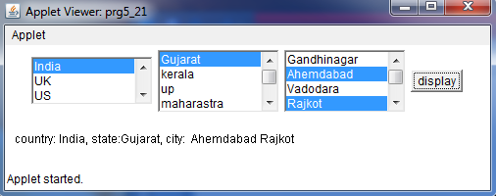
- Login form
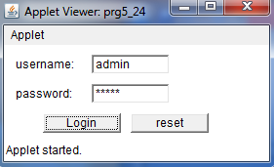
- Change background color by selection from choice component (ueItemListener)
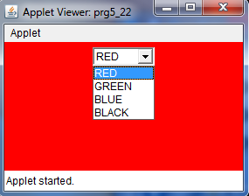
- Employee salary with proper exception, use various components for various input. Display detail in text area. Use layout to set component at particular place.
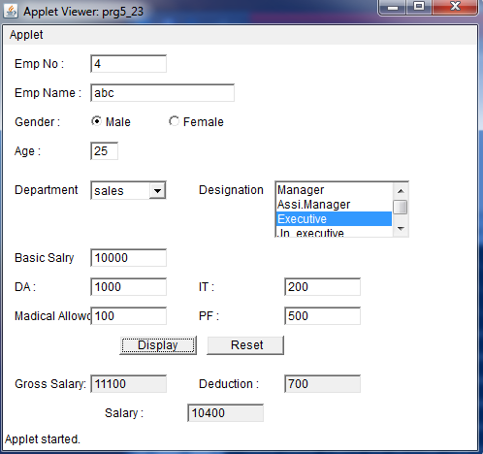
- Write An Applet Program To Copy Selected Option Value In To Textfield.
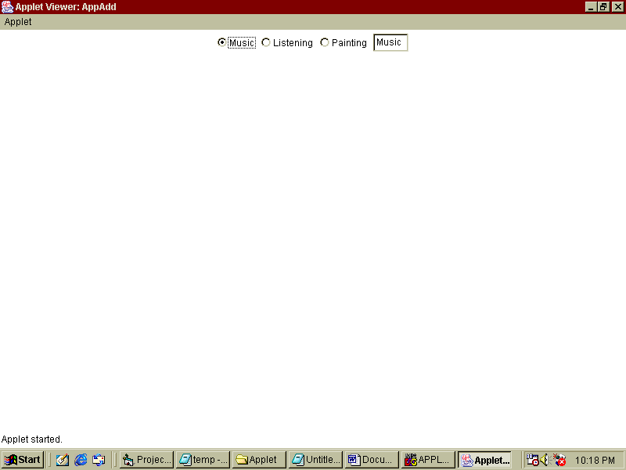

- Write An Applet Program To Do Calculation Based On Selected Operator From Choice Using ActionListener.
